# AWS AI-Driven Social Media Dashboard

AI-Driven Social Media Dashboard monitors and ingests specified tweets using stream processing and leverages a serverless architecture and ML services (Amazon Translate and Amazon Comprehend) to translate and extract insights from those tweets. The diagram below presents the architecture.

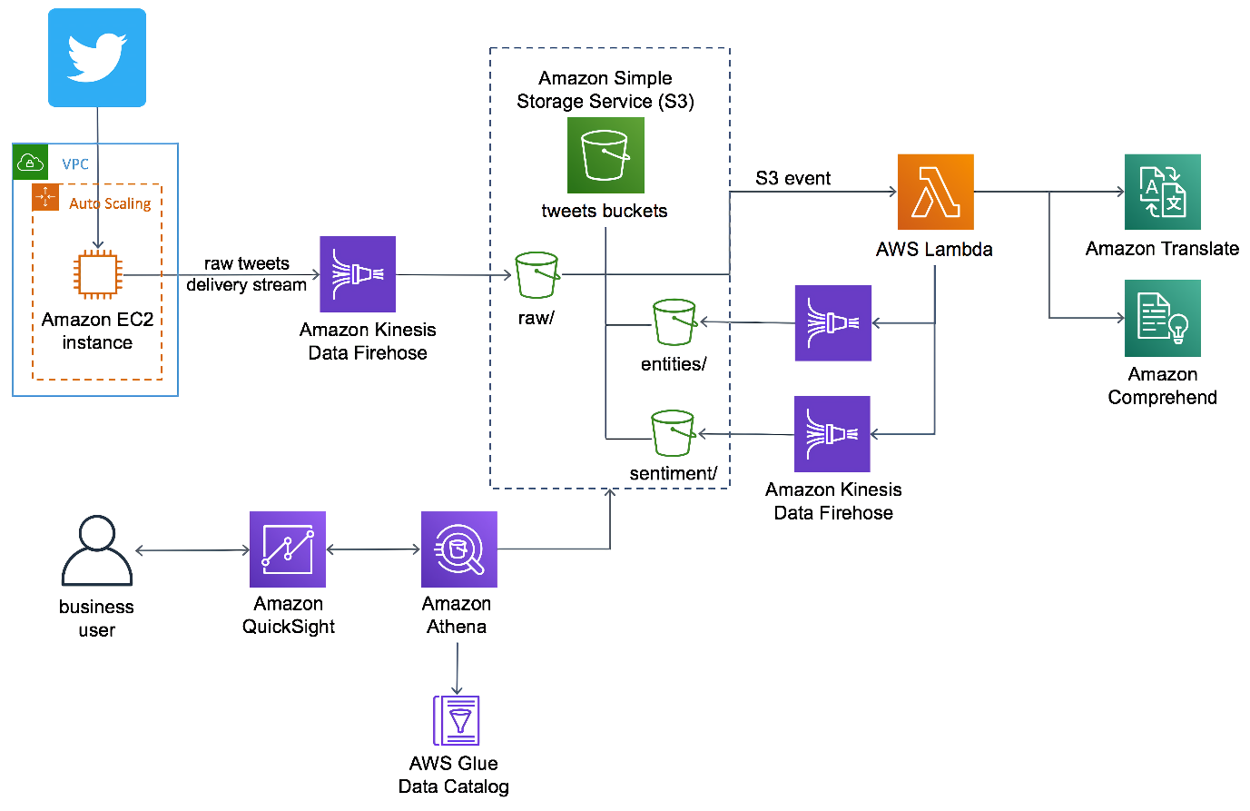

#### AI-Driven Social Media Dashboard architecture

AI-Driven Social Media Dashboard deploys an [Amazon Elastic Compute Cloud](https://aws.amazon.com/ec2/) (Amazon EC2) instance running in an [Amazon Virtual Private Cloud](https://aws.amazon.com/vpc/) (Amazon VPC) that ingests tweets from Twitter. An [Amazon Kinesis Data Firehose](https://aws.amazon.com/kinesis/data-firehose/) delivery stream loads the streaming tweets into the *raw* prefix in the solution's [Amazon Simple Storage Service](https://aws.amazon.com/s3/) (Amazon S3) bucket. Amazon S3 invokes an [AWS Lambda](https://aws.amazon.com/lambda/) function to analyze the raw tweets using [Amazon Translate](https://aws.amazon.com/translate/) to translate non-English tweets into English, and [Amazon Comprehend](https://aws.amazon.com/comprehend/) to use natural-language-processing (NLP) to perform entity extraction and sentiment analysis.

A second Kinesis Data Firehose delivery stream loads the translated tweets and sentiment values into the *sentiment* prefix in the Amazon S3 bucket. A third delivery stream loads *entities* in the entities prefix using in the Amazon S3 bucket.

The Guidance also deploys a data lake that includes [AWS Glue](https://aws.amazon.com/glue/) for data transformation, [Amazon Athena](https://aws.amazon.com/athena/) for data analysis, and [Amazon QuickSight](https://aws.amazon.com/quicksight/) for data visualization. AWS Glue Data Catalog contains a logical database which is used to organize the tables for the data on Amazon S3. Athena uses these table definitions to query the data stored on Amazon S3 and return the information to an Amazon QuickSight dashboard.

## Features

#### Machine Learning

Use ML services to extract meaningful insights and customer sentiment from tweets.

#### Automation

Automatically launch and configure the services necessary to ingest, store, translate, analyze, and visualize customer feedback from tweets.

#### Visualization

Leverage Amazon QuickSight to build insightful dashboards from the analyzed data.

Example Code on GitHub: <https://github.com/awslabs/ai-driven-social-media-dashboard>